use project;

create table proj_detail(id int primary key auto_increment, project_name varchar(250), start_date datetime, end_date datetime);

insert into proj_detail(project_name, start_date, end_date)
values ('comcast', '2023-01-12 10:00:00', '2030-12-31 00:00:00'),
('gemini', '2011-01-01 06:00:00', '2025-12-31 00:00:00'),
('medac', '2019-01-12 01:00:00', '2028-12-31 00:00:00'),
('pwc', '2021-08-01 08:00:00', '2031-12-31 00:00:00'),
('nyc langue', '2020-11-22 10:00:00', '2029-12-31 00:00:00');

select * from proj_detail;

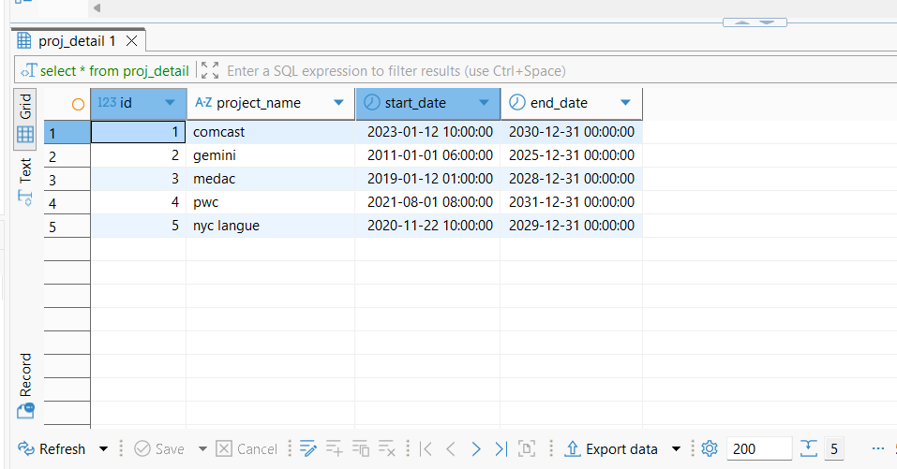

select project_name,start_date,date(start_date) as date,
year(start_date) as year,
time(start_date) as time,
monthname(start_date) as month,
day(start_date) as day from proj_detail;
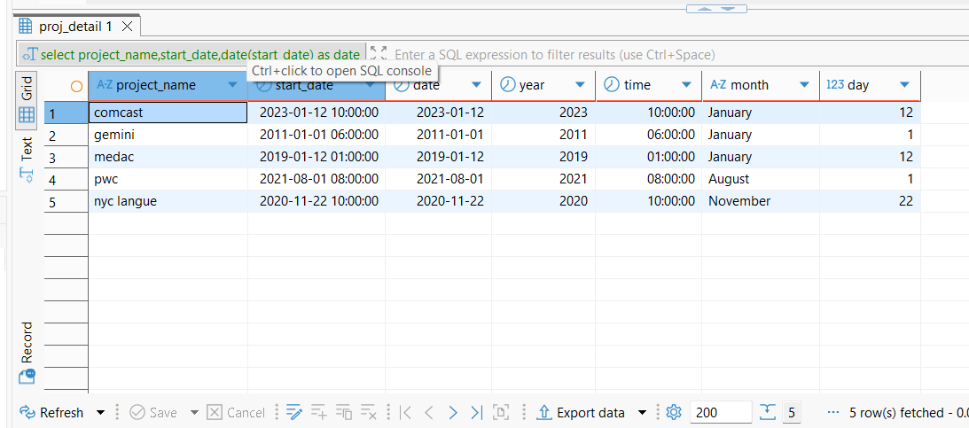

select project_name,start_date, DATEDIFF(start_date,current_date()) as difference from proj_detail;
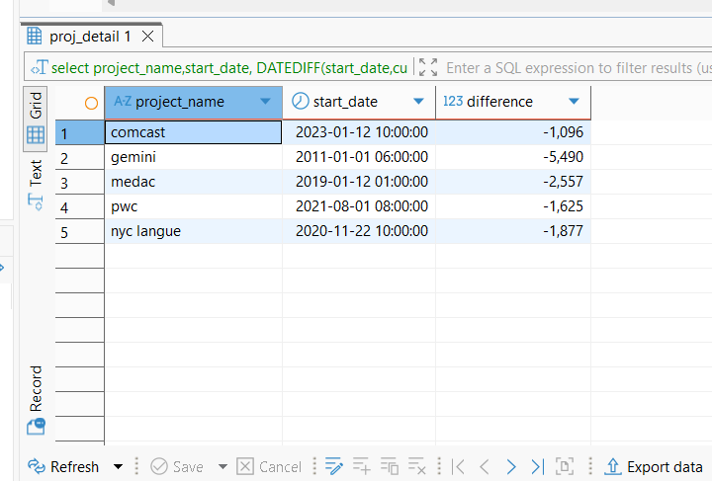

select project_name,start_date, DATEDIFF(end_date,current_date()) as remaining_days from proj_detail;
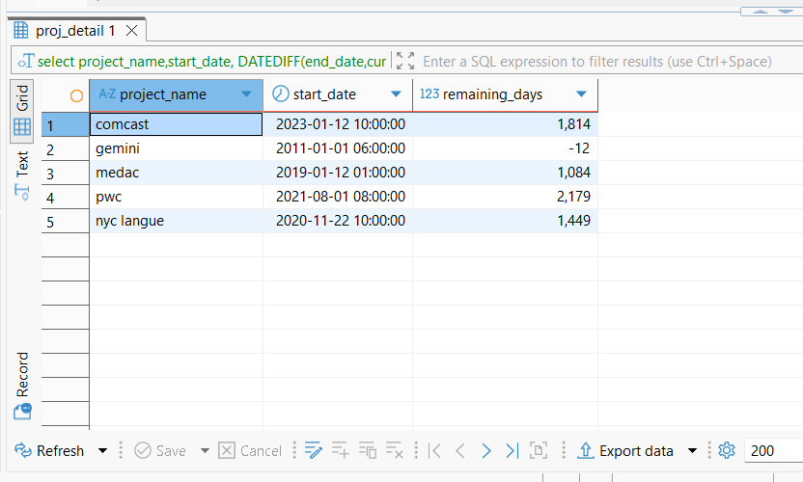

use project;

create table employee( id int primary key auto_increment, name varchar(250), dept varchar(250), salary int, project varchar(250));

insert into employee(name, dept, salary, project) values ('Ajay', 'IT', 55000, 'comcast'), ('kiran', 'IT', 55000, 'pwc'), ('Sampath', 'IT', 55000, 'gemini'), ('Vinay', 'IT', 55000, 'pwc'), ('Dravid', 'HR', 40000, 'comcast'), ('Varun', 'HR', 40000, 'nyc lanuge'), ('Barathi', 'IT', 55000, 'nyc lanuge'), ('Hari', 'HR', 40000, 'gemini'), ('Gopi', 'Finance', 60000, 'comcast'), ('Arasi', 'Finance', 60000, 'pwc'), ('Praveen', 'Finance', 60000, 'nyc lanuge'), ('Vijay', 'Finance', 60000, 'gemini');

select * from employee;
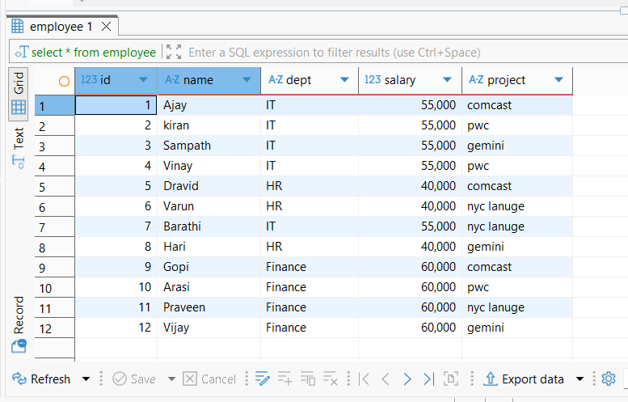

select * from employee order by salary asc;
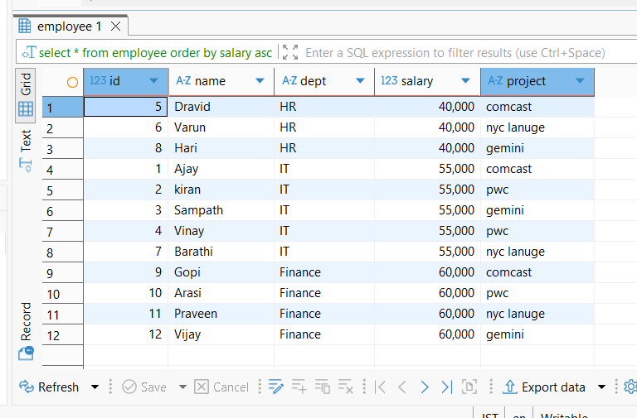

select dept, count(*) from employee group by dept;
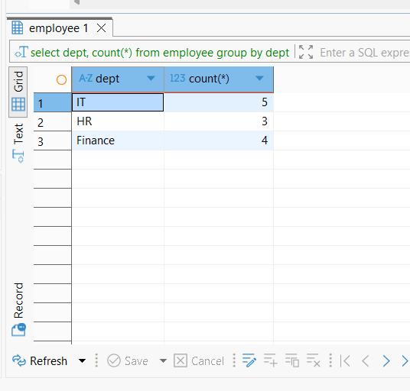

select dept, count(*) from employee group by dept having count(*) > 3;
